**FPT ACADEMY INTERNATIONAL**



## FPT – APTECH COMPUTER EDUCATION

**School Infor**

|  |  |  |  |
| --- | --- | --- | --- |
| **Center Name** | | FPT – Aptech – HCM2  Address: 590 Cach Mang Thang Tam, District 3, Ho Chi Minh City | |
| **Instructor** |  | Ms. Le Mong Thuy |  |
| **Class** |  | T1.2208.A0 |  |
| **Group** |  | 8 |  |
| **Group members** | | **Name** | **Student ID** |
|  |  | Le duy Nien | Student1387817 |
|  |  | Nguyen Quoc kiet | Student1408019 |
|  |  | Nguyen Phuong Trung Tin | Student1409141 |
| **Duration** | Start date | 14th Nov 2022 |  |
| End date | 14th Dec 2022 |  |

**This is to certify that**

**Mr.:**

Le Duy Nien

Nguyen Quoc Kiet

Nguyen Phuong Trung Tin

**has successfully designed & developed**

eProject: School Infor website

**Submitted by:**

Nguyen Phuong Trung Tin

**Date of issue:**

**Authorized Signature:**

**TABLE OF CONTENTS**

****FPT – APTECH COMPUTER EDUCATION 1****

****TABLE OF CONTENTS**** ****3****

****ACKNOWLEGMENT**** ****3****

****SYNOSIS**** ****3****

****PROBLEM DEFINITION**** ****3****

****CUSTOMER'S REQUIREMENTS SPECIFICATIONS (CRS) 4****

****Business/Project Objective**** ****4****

****Hardware/ Software Requirements**** ****5****

****SCOPE OF THE WORK (IN BRIEF) 6****

****Architecture and design of the system 7****

****Diagram of the website 8****

****TASK SHEET REVIEW 1 9****

****SITE MAP 10****

****MOCK OF THE WEBSITE 1********1****

***1. Home 1******1***

***2. Information 1******2***

***3. Education Program 1******3***

***4. School 1******4***

***5. Contact 1******5***

****TASK SHEET REVIEW 2 18****

WEBSITE DESCRIPTION ****1********9****

RESPONSIVE****28****

[****JAVASCRIPT DESCRIPTION****](#Javascript) ****30****

****TASK SHEET REVIEW 3**** ****47****

# ACKNOWLEGMENT

On behalf of team members. I would like to thank everyone who supported my team to successfully complete this eProject report. Especially, our teacher, she has supported us a lot since we started studying at FPT Aptect. With this eProject, she guided us very meticulously, enthusiastically and strictly. With her guidance, we were able to successfully complete this project. Besides, I also want to thank all the team members, each of whom worked hard to complete the eProject in earnest during the month of working together. Finally, our group would like to say thank you to my classmates and family for sharing and creating for the group the best environment to focus on the project, motivating the members to achieve their goals.

# SYNOSIS

The goal of the website “SchoolsInfo” seems very necessary. SchoolsInfo is a website that provides

Information about the various schools available in the city. People interested in

Admission seekers for their children can see this site where they can know where

all fields set and all other facilities available in that tool.

# PROBLEM DEFINITION

The Web site is to be created based on the following requirements.

1) The Home Page should be created making use of Sections with a suitable

logo, the header section can be added which will show related images.

2) The site must contain the links to navigate through any category for the

information.

3) The site should display a menu which will contain the options for brief

introduction about the various schools , location and any other information if

required.

4) The web site should also provide the option of searching the schools based on

location and facilities.

5) Also have a Site Map option where viewers can see which all schools are available

in our web site and can easily know where it is situated in the city. Their location

should be displayed using GeoLocation API (eg. GoogleMaps)

6) The information about the school should include following major details

- What is the maximum intake capacity of students?

- Whether library is available

- Availability of canteen facility

- Availability of boarding

- What type of sports options available

7) A brief summary of a particular school including list of facilities available,

should be displayed on the Web Page along with the pictures but detailed

features should be stored in individual Word documents which can be

downloaded or viewed by the User who wishes to see the same.

# CUSTOMER'S REQUIREMENTS SPECIFICATIONS (CRS)

**Client: School Infor**

### Business/Project Objective:

Currently people generally find out the details about the schools from relatives/friends

or visiting schools personally. But this is becoming difficult as many new schools are

being established everywhere. Thus this can be overcome by the proposed system called

“SchoolsInfo” where viewing all schools and related information in particular area from

anywhere.

You are supposed to create a website for them with the below mentioned requirement

specifications.

The website is to be developed for the Windows Platform using HTML5, JavaScript and

Geolocation. The site should work well in all leading browsers including Chrome, IE,

Firefox etc.

**Input to the system:**

- Search for information about schools.

- Feedback about school.

**Output from the system:**

- Perform search based on: features and information...

- Display fields by search content.

- The website can provide a brief history of the fields in my site...

**Process**:

* + - * Validate data input from users.

**Expected delivery date:** 14-Dec-2022.

**List of deliverables:**

- Document Word, PDF.

- User Guide.

- Source code.

### Hardware/ Software Requirements:

* **For developer**

**Hardware**

* A minimum computer system that will help you access all the tools in the

courses is a Pentium 166 or better

* 64 Megabytes of RAM or better

**Software**

* Notepad/HTML editor
* Dreamweaver
* IE 5.0/ Netscape 6.0.
* **For web users**

**Hardware**

* + Intel Pentium 4 processor or higher
  + 512 Megabytes of RAM or higher

**Software**

* + Windows XP OS or higher
  + Web browsers such as IE, Chrome or Firefox are supporting HTML5, CSS3 and Javascript.

# SCOPE OF THE WORK (IN BRIEF)

After a long and detailed discussion, our group has decided to create a website contain the following webpages:

1. ***Home***:Home page with items information,TraningAdustry,Primary School,Contact.
2. ***Information***:. offers some helpful information about schools for parents to help them make the right choices
3. ***Education Program***: primary school : training from grade 1 to grade 5
4. ***Schools***: information about the Primary School
5. ***Contact***: advise parents to choose which school is right for their child.

# ARCHITECTURE AND DESIGN OF THE SYSTEM

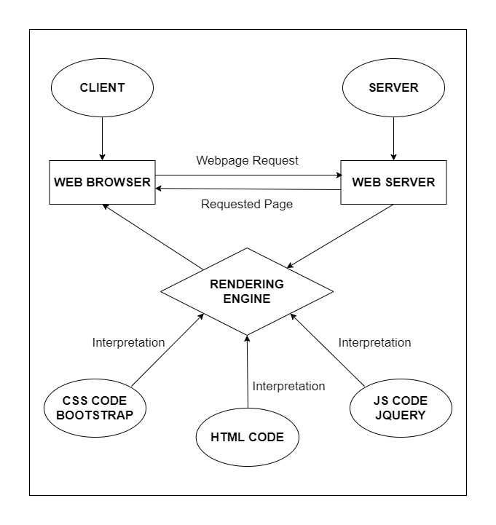

# DIAGRAM OF THE WEBSITE

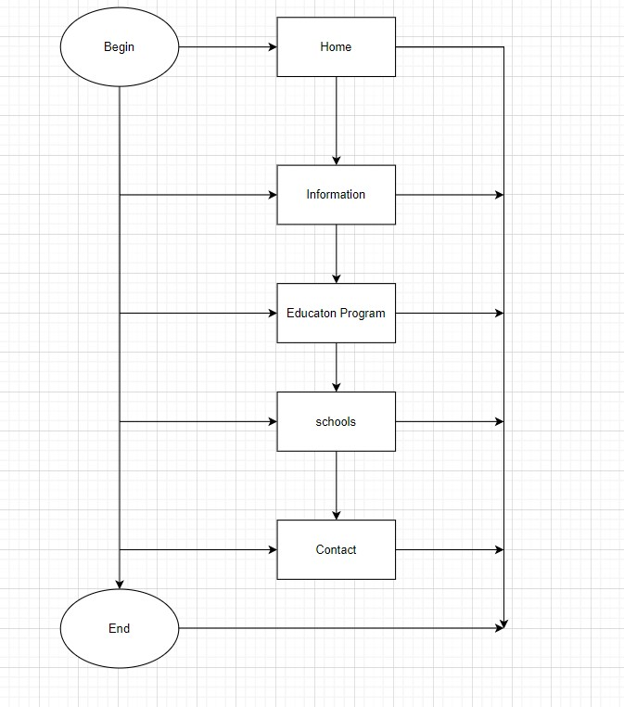



# TASK SHEET REVIEW 1

|  |  |  |  |  |  |  |  |
| --- | --- | --- | --- | --- | --- | --- | --- |
| **Project Ref. No.:**  **eP/Advertisement Portal Management**  **System/01** | | **Project Title:** | **Activity Plan Prepared By:** | **Date of Preparation of Activity Plan:** | | | |
| **Sr.**  **No.** | **Task** | **Actual**  **Start**  **Date** | **Actual Days** | **Team**  **Mate Names** | **Status** |
| 1 | Problem Statement | School Infor | Nien | 14-July-22 | 1 | Tin | Completed |
| 2 | Analysis of School Infor requirements about the website | 14-July-22 | 1 | Tin | Completed |
| 3 | The scope of the work (in brief) | 14-July-22 | 1 | Nien | Completed |
| 4 | Architecture and design of the system | 14-July-22 | 1 | Nien | Completed |
| 5 | Diagram of the website | 14-July-22 | 1 | Kiet | Completed |
| 6 | Task Sheet | 14-July-22 | 1 | Kiet | Completed |

|  |  |
| --- | --- |
| **Date:** | |
| Signature of Instructor:  **Ms. Le Mong Thuy** | Signature of Team Leader:  **Nguyen Phuong Trung Tin** |

# SITE MAP

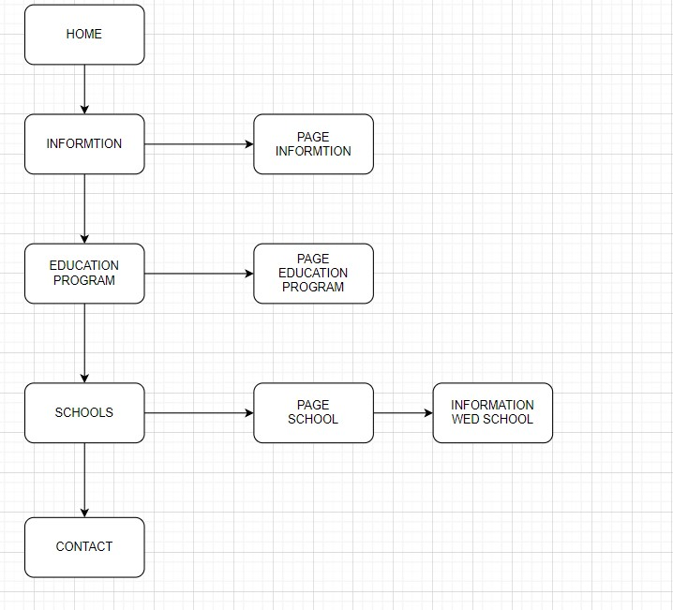

# MOCK OF THE WEB SITE

1. **Home**

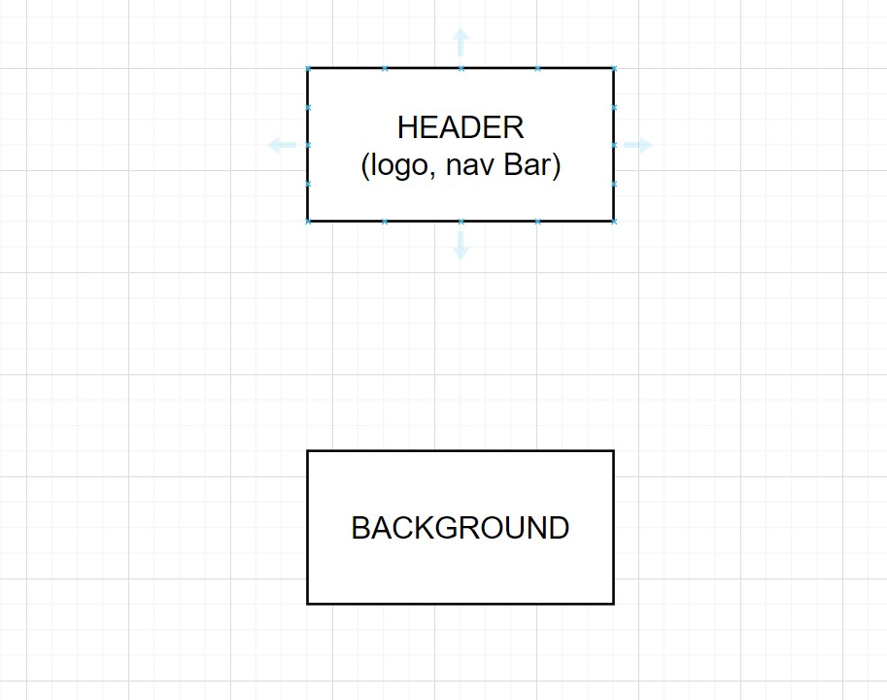

1. **Information**

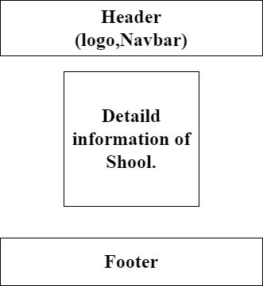

1. **Training adustry**

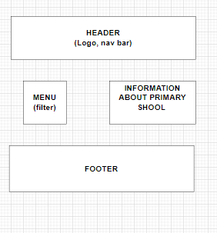

**4. Schools**

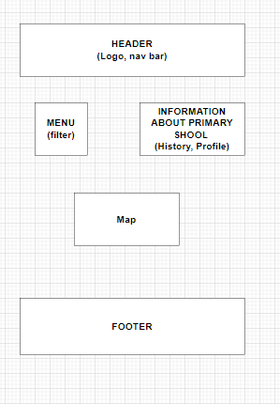

**5. Contact.**

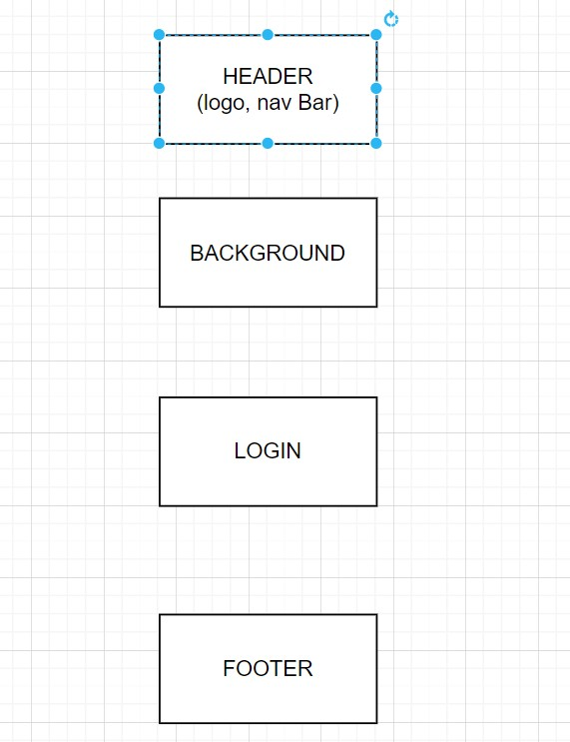

# TASK SHEET REVIEW 2

|  |  |  |  |  |  |  |  |
| --- | --- | --- | --- | --- | --- | --- | --- |
| **Project Ref. No.:**  **eP/Advertisement Portal Management**  **System/01** | | **Project Title:** | **Activity Plan Prepared By:** | **Date of Preparation of Activity Plan:** | | | |
| **Sr.**  **No.** | **Task** | **Actual**  **Start**  **Date** | **Actual Days** | **Team**  **Mate Names** | **Status** |
| 1 | Site Map | School Infor | Nien | 16-Nov-22 | 1 | Tin | Completed |
| 2 | Mock of the website | 16-Nov-22 | 2 | Nien | Completed |
| 3 | Task sheet | 16-Nov-22 | 2 | Kiet | Completed |

|  |  |
| --- | --- |
| **Date:** | |
| Signature of Instructor:  **Ms. Le Mong Thuy** | Signature of Team Leader:  **Nguyen Phuong Trung Tin** |

# WEBSITE DESCRIPTION

1. **Homepage**
2. Description

Home page displays following information:

- Slide show programs, services and product promotions

- Schools

- Each Primary School

-Education Programs

1. Screen shot

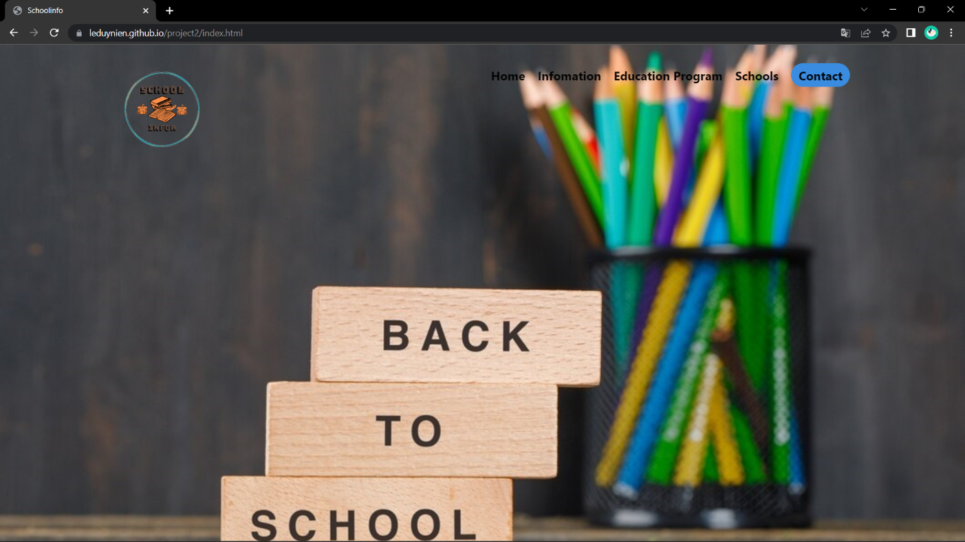

1. **Information**
2. Description

This school page displays following information:

- All school that being sold at (Home, Information, Education Program, Primary school), when click on quick view item, it will show the detail of that item.

- Schools can be compared with schools of the same category

- Schools can sort by quality and price

1. Screen shot

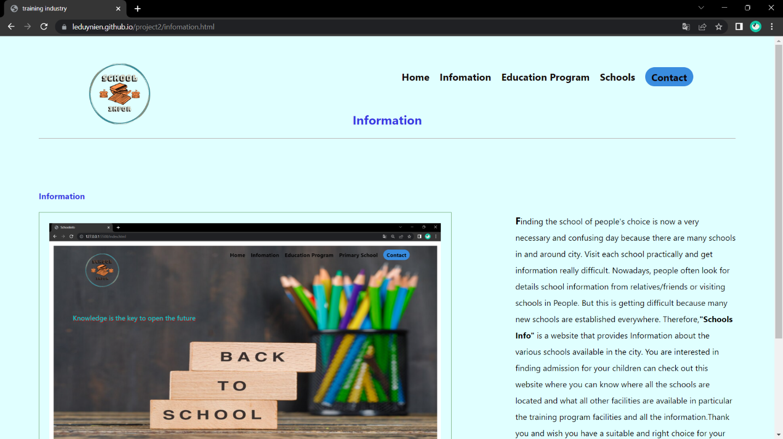

1. **Education Program**
2. Description

The blog page displays following information:

- News.

- Information of product.

- Events, promount.

1. Screen shot



1. **Schools**
2. Description

- This page displays information about the schools and services that we provide to people.

- Show satisfied customers.

1. Screen shot

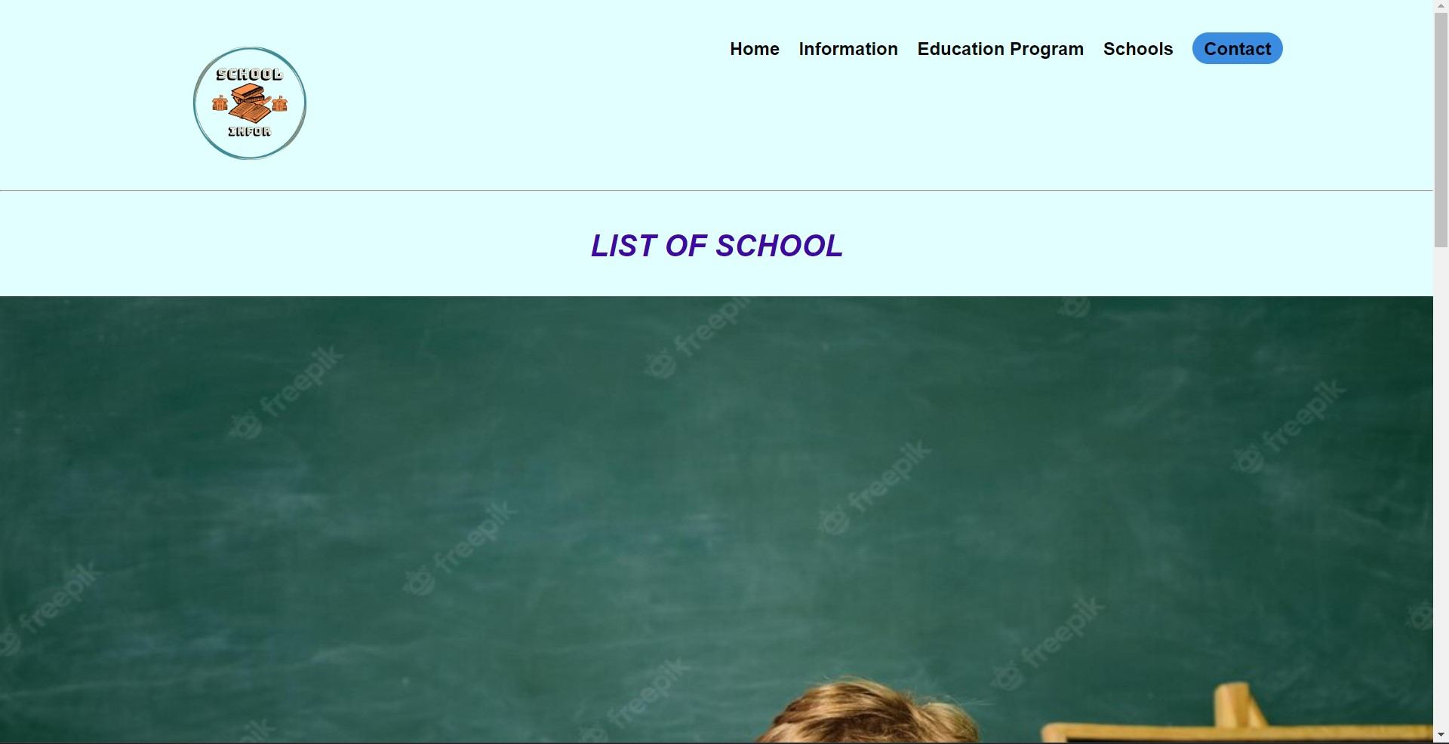

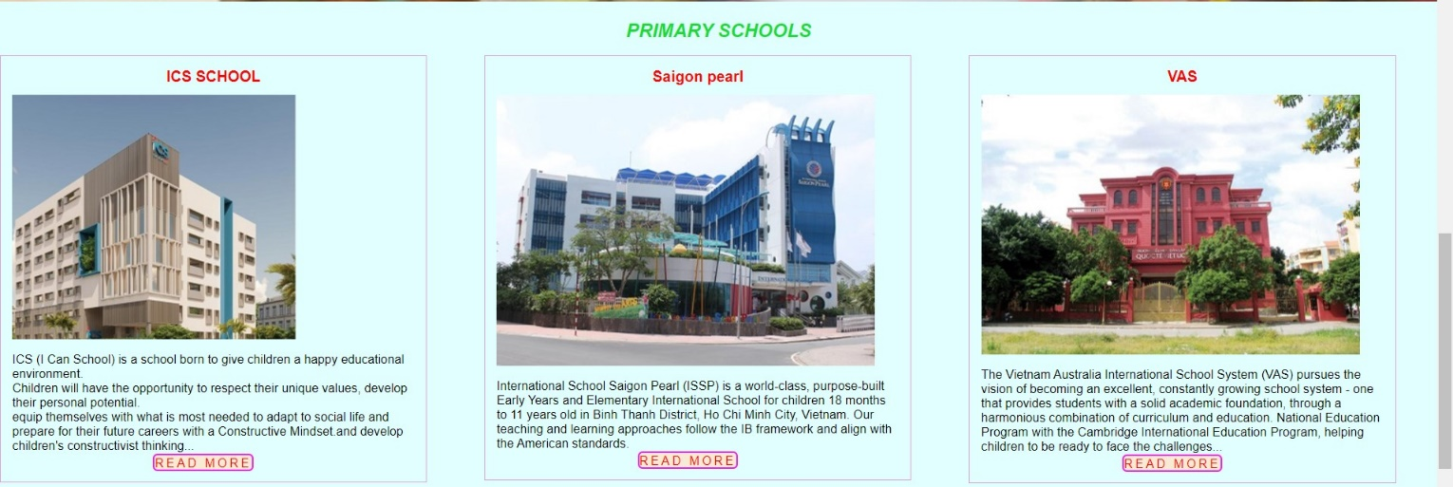

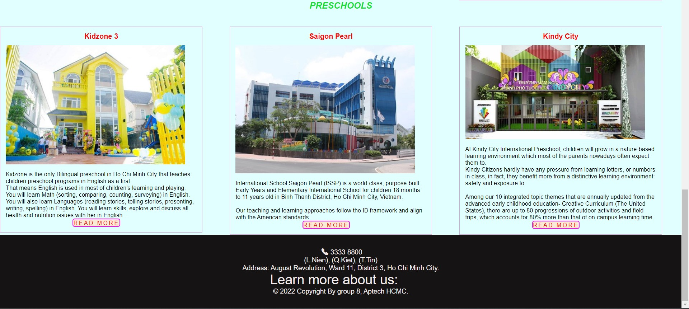

1. **Contact**
2. Description

This page displays contact information: location, telephone number, email and a quick contact form for customer

1. Screen shot

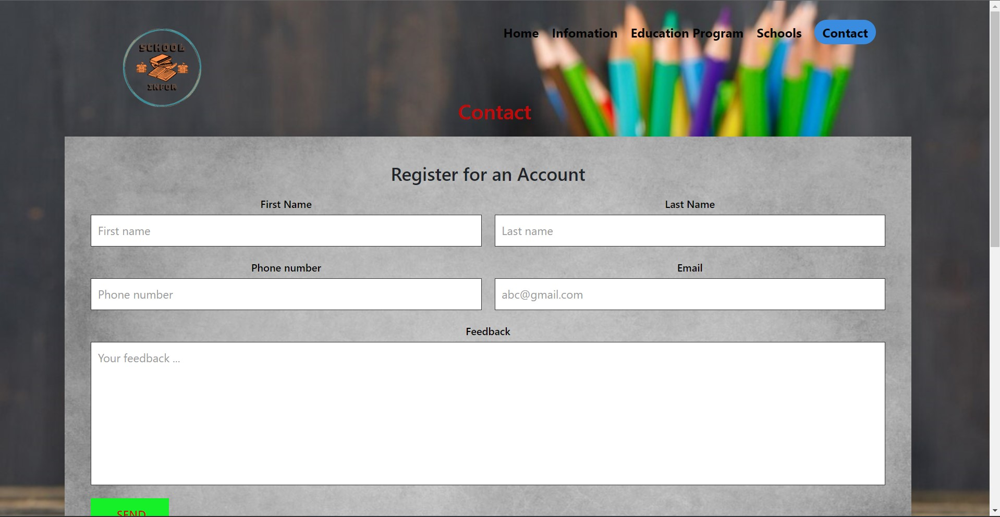

**RESPONSIVE**

The page has responsive feature for small screen device such as smart phone, tablet, etc.

# TASK SHEET REVIEW 3

|  |  |  |  |  |  |  |  |
| --- | --- | --- | --- | --- | --- | --- | --- |
| **Project Ref. No.:**  **eP/Advertisement Portal Management**  **System/01** | | **Project Title:** | **Activity Plan Prepared By:** | **Date of Preparation of Activity Plan:** | | | |
| **Sr.**  **No.** | **Task** | **Actual**  **Start**  **Date** | **Actual Days** | **Team**  **Mate Names** | **Status** |
| 1 | Home Page | Shoolinfo | Nien | 18-Nov-22 | 1 | Nien | Completed |
| 2 | infomation | 20-Nov-22 | 3 | Kiet | Completed |
| 3 | Education program | 18-Nov-22 | 2 | Nien | Completed |
| 4 | Schools | 20-Nov-22 | 2 | Tin | Completed |
| 5 | Contact | 18-Nov-22 | 2 | Nien | Completed |

|  |  |
| --- | --- |
| **Date:** | |
| Signature of Instructor:  **Ms. Le Mong Thuy** | Signature of Team Leader:  **Nguyen Phuong Trung Tin** |